**DEVELOPMENT OF AN ALGORITHM TO PREDICT THE FINAL COLOR OF LITHIUM DISILICATE CAD/CAM CERAMIC VENNER RESTORATIONS**

Mateus Garcia Rocha ***(Student)***

Savio Saldanha ***(Mentor)***

# Abstract

**Objective:** The aim of this research is to develop an algorithm to predict the final color of lithium disilicate CAD/CAM ceramic veneer restorations based on the substrate shade, ceramic shade, thickness and translucency. **Methods:** Lithium disilicate glass-based ceramics (IPS e.max® CAD) in 12 different shades will be sectioned in thicknesses of 0.3, 0.5, 0.7 and 1.2 mm. An experimental translucent resin-based cement with a refractive index of 1.5229 will be produced. The CIELab coordinates (L*, a*, b*) of each specimen will be obtained with a D65 illuminant over four different backgrounds (black, white, A1 and A3) interposed with the experimental resin cement using a calibrated spectrophotometer with target mask with sensor-opening diameter of 3 mm. The color change (ΔE00) from the substrate to final restoration will be calculated according to the CIEDE2000 formula. Data will be analyzed statistically with α =0.05 and β = 0.2. The values in ΔE00 as well as the all the CIELab values for each one of the experimental groups are going to be inserted into a statistical software and the data will be submitted to a multivariate linear regression. The regression model will be adjusted according to the weights of each dependent variable to achieve the model best-fitting. The variable processing and the set of rules to be followed in the algorithm calculations based on the regression analysis will be translated to a Python general-purpose programming language for future application development.

# Clinical Relevance

The development of the algorithm will provide the advantage of selecting and predicting the final color of lithium disilicate ceramic veneers based on the substrate color and ceramic restoration characteristics using artificial intelligence processing.

1. **Background & Rationale**

The evolution of dental ceramics and adhesive procedures allowed the development of all-ceramic restorations and more conservative preparation designs.1 Conservative preparations become one of the desired standards for anterior crowns and veneers. These restorations are largely affected by factors as substrate shade, cement, ceramic thickness, ceramic shade, and ceramic translucency.2,3

The advent of CAD-CAM systems and the chairside CAD-CAM dentistry is an extraordinary achievement that gives the dentist the charge for selecting and handling the ceramic materials and, consequently, the final results' responsibility.4 It is important to note that monolithic restorations are a rule of thumb for dentists who use CAD-CAM systems, increasing the challenge of achieving a natural and satisfactory result, especially when discolored substrates are present.4,5 Digital dentistry has been successful when determining the restorations' shape and position; however, the selection of the restoration's shade still relies on the dentist and dental technician's experience and ability. Several researchers have addressed this field, seeking results that would allow more shade predictability while selecting the CAD-CAM material. However, not all of them are replicable in other contexts due to the vast number of clinical variables. 6-8

Instrumental shade evaluation using spectrophotometers provides objective data that is used for shade evaluation and matching.9 However, there is no method to combine the CIELab coordinates (L*, a*, b*) obtained from the tooth substrate and ceramic to predict the best ceramic type, shade, and thickness. The understanding of these interactions would extend the use of spectrophotometers in dentistry.

The aim of this research is to develop an algorithm to predict the final color of lithium disilicate CAD/CAM ceramic veneer restorations based on the substrate shade, ceramic shade, ceramic thickness, and ceramic translucency.

1. **Specific aims & Hypothesis**

The specific aims are: 1 - Evaluate the L* a* b* of monolithic and bilayer ceramics with different thicknesses, shade and translucency, cemented on white, black, A1 and A3 substrates with translucent resin cement. 2 - Create an algorithm based on the regression analysis of the color coordinate parameters (CIE L* a* b*) to predict the final color of the ceramic restoration and the color change (ΔE00) from the substrate initial color. The null hypothesis tested in this study will be: HØ1 - There will be a significant difference in the L* a* b* color coordinates of monolithic and bilayer ceramics with different thicknesses, shade and translucency cemented on white, black, A1 and A3 substrates with translucent resin cement. HØ2 - The algorithm created using the color coordinate parameters (CIE L* a* b*) will be able to predict the final color of the ceramic restoration and the color change (ΔE00) from the substrate initial color.

1. **Work plan (Methods)**

Lithium disilicate glass-based ceramics (IPS e.max® CAD, C14, Ivoclar Vivadent, Schaan Liechtenstein) in 12 different shades (**HT** - *BL2, B1, A1, A3* ; **MT** - *BL2, B1, A1, A3*; **LT** - *BL2, B1, A1, A3*) will be used on this study. The stubs of the CAD/CAM blocks will be removed, and the blocks will be invested in dental stone (Type 4 gypsum whipmix). The assembly will be mounted in a precision diamond saw machine and the blocks will be sectioned. Specimens (n = 5) perpendicular to the long axis of the block will be obtained with thicknesses of 0.3, 0.5, 0.7 and 1.2 mm. An experimental translucent resin-based cement with a refractive index of 1.5229 and without photoinitiators (Table 1) will be produced to simulate the cementation of the ceramic veneer on the substrate. This will be mimicking the refractive index changes and the light propagation through the interfaces between the ceramic-cement and cement substrate. Also, it will allow the use of the multiple uses of the samples and substrates, consequently reducing the variation withing the study and reducing the number of samples needed.

Four different substrates will be used: A white background; A black background; a IPS Empress® LT A1 CAD/CAM block; a IPS Empress® LT A3 CAD/CAM block. The color parameters of each specimen will be obtained with a D65 illuminant over the different backgrounds interposed with the translucent resin cement using a calibrated spectrophotometer (CMD-700, Konica Minolta, Tokyo, Japan) with target mask with sensor-opening diameter of 3 mm. The sensor opening of the spectrophotometer will be placed in the center of each specimen and three measurements will be collected in both specular component mode setting. The CIELab coordinates (L*, a*, b*) from the specimens will be used to evaluate color change (ΔE00) from the substrate to the surface of the veneer according to the CIEDE2000 formula (CIE, 2004). ∆E00 = [(∆L/KL.SL)2 + (∆C/KC.SC)2 + (∆H/KH.SH)2 + RT.( ∆C/KC.SC).( ∆H/KH.SH)]0.5, and ∆L, ∆C and ∆H are the differences in lightness, chroma and hue, and Rt is a function (the so-called rotation function) that accounts for the interaction between chroma and hue differences in the blue region. Weighting functions, SL, SC, and SH adjust the total color difference for variation in the location of the color difference pair in L, a, and b coordinates, and the parametric factors KL, KC, and KH are correction terms for the experimental conditions, which were set to 1. Differences in each inherent color parameter were also determined as ΔL*, Δa*, and Δb* by subtracting each specimen from the substrate color co-ordinate parameter value (+a* = red, −a* = green; +b* = yellow, −b* = blue; +L* = white, -L* = black.

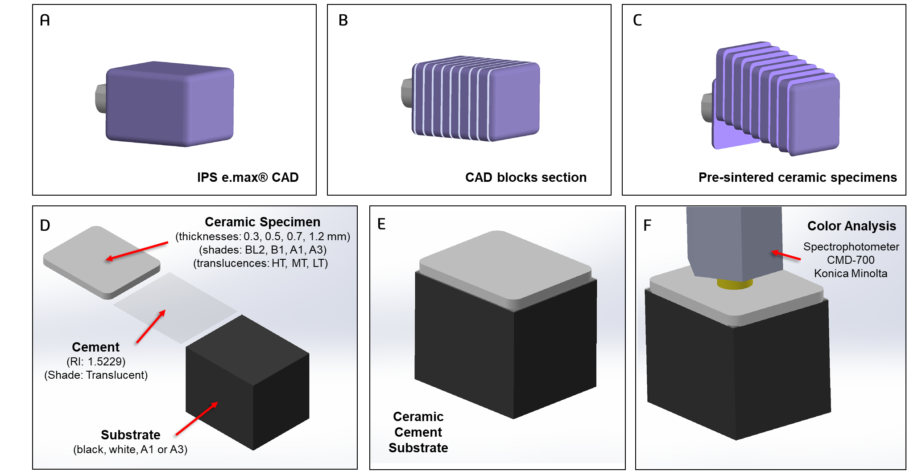

Figure 1 - Experimental Set up. (A) C14 Emax CAD blocks. (B) Sectioning of the blocks in different thickness. (C) Specimens before sintering/crystallization. (D-E) Specimens assembly and evaluation according to different thicknesses, shades and translucencies interposed by a translucent cement over different backgrounds. (E) Spectrophotometric analysis using the CMD-700 Konica Minolta.

1. **Statistical Analysis**

Data will be entered into statistical analysis software (Stata/MP 13, StataCorp, College Station, TX, USA) and will be checked for normality using Shapiro–Wilk's test and for variance homoscedasticity using Lavene's test. Statistical analyses will be performed according to the different experimental designs with a level of significance of α = 0.05. A power analysis will be conducted to determine the sample size for each experiment to provide a power of at least 0.8 at a significance level of 0.5 (β = 0.2). The regression analysis will depend on the normality of the data, the variance and the regression fitting distribution. The values in ΔE00 as well as the all the CIELab values for each one of the experimental groups are going to be inserted into a statistical software and the data will be submitted to a multivariate linear regression. The regression model will be adjusted according to the weights of each dependent variable to achieve the model best-fitting. The variable processing and the set of rules to be followed in the algorithm calculations based on the regression analysis will be translate to a Python general-purpose programming language for future applications development.

**References**

1. Imburgia M, Lerner H, Mangano F. A Retrospective Clinical Study on 1075 Lithium Disilicate CAD/CAM Veneers with Feather-Edge Margins Cemented on 105 Patients. Eur J Prosthodont Restor Dent. 2021 Jan 7. doi: 10.1922/EJPRD_2248. Mangano10. Epub ahead of print. PMID: 33416217.
2. Iravani M, Shamszadeh S, Panahandeh N, Sheikh-Al-Eslamian SM, Torabzadeh H. Shade reproduction and the ability of lithium disilicate ceramics to mask dark substrates. Restor Dent Endod. 2020 Jul 16;45(3):e41. doi: 10.5395/rde.2020.45.e41. PMID: 32839722; PMCID: PMC7431926.
3. Della Bona A, Pecho OE, Ghinea R, Cardona JC, Pérez MM. Colour parameters and shade correspondence of CAD-CAM ceramic systems. J Dent. 2015;43(6):726-734. doi:10.1016/j.jdent.2015.02.015
4. Shenoy A, Shenoy N. Dental ceramics: An update. *J Conserv Dent*. 2010;13(4):195-203. doi:10.4103/0972-0707.73379
5. Czigola A, Abram E, Kovacs ZI, Marton K, Hermann P, Borbely J. Effects of substrate, ceramic thickness, translucency, and cement shade on the color of CAD/CAM lithium-disilicate crowns. J Esthet Restor Dent. 2019 Sep;31(5):457-464. doi: 10.1111/jerd.12470. Epub 2019 Apr 8. PMID: 30957412.
6. Paravina RD, Pérez MM, Ghinea R. Acceptability and perceptibility thresholds in dentistry: A comprehensive review of clinical and research applications. J Esthet Restor Dent. 2019;31(2):103-112. doi:10.1111/jerd.12465
7. Czigola A, Abram E, Kovacs ZI, Marton K, Hermann P, Borbely J. Effects of substrate, ceramic thickness, translucency, and cement shade on the color of CAD/CAM lithium-disilicate crowns. J Esthet Restor Dent. 2019 Sep;31(5):457-464. doi: 10.1111/jerd.12470. Epub 2019 Apr 8. PMID: 30957412.
8. Kang W, Park JK, Kim SR, Kim WC, Kim JH. Effects of core and veneer thicknesses on the color of CAD-CAM lithium disilicate ceramics. J Prosthet Dent. 2018;119(3):461-466. doi:10.1016/j.prosdent.2017.04.005
9. Pecho OE, Ghinea R, Alessandretti R, Pérez MM, Della Bona A. Visual and instrumental shade matching using CIELAB and CIEDE2000 color difference formulas. Dent Mater. 2016 Jan;32(1):82-92. doi: 10.1016/j.dental.2015.10.015. Epub 2015 Nov 28. PMID: 26631341.